|  |  |  |  |  |  |  |  |  |  |  |  |  |  |
| --- | --- | --- | --- | --- | --- | --- | --- | --- | --- | --- | --- | --- | --- |
|  |  |  |  |  |  |  |  |  |  |  |  |  |  |
|  |  |  |  |  |  |  |  |  |  |  |  |  |  |
|  |  |  |  |  |  |  |  |  |  |  |  |  |  |

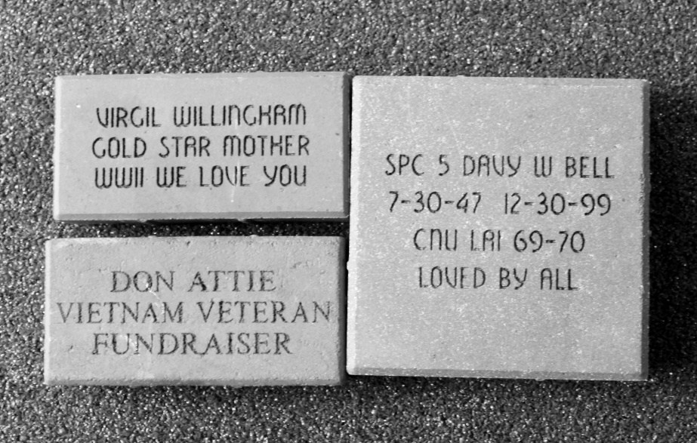

**I would like to order _________ 4” x 8” Paver at $50.00 each**

**3 lines with 14 characters each (Includes text, spaces, and punctuation)**

**Make Checks or Money Orders to:**

**Friends of Sheffield Lake Veterans Park**

**Mail To :**

**Veterans Park walkway Pavers c/o Veteran Joseph Gee 272 Gayle Drive . Sheffield Lake Ohio .44054**

**Any Questions Please Call**

**Joseph & Rosa Gee (440)-949-4883**

|  |  |  |  |  |  |  |  |  |  |  |  |  |  |  |  |
| --- | --- | --- | --- | --- | --- | --- | --- | --- | --- | --- | --- | --- | --- | --- | --- |
|  |  |  |  |  |  |  |  |  |  |  |  |  |  |  |  |
|  |  |  |  |  |  |  |  |  |  |  |  |  |  |  |  |
|  |  |  |  |  |  |  |  |  |  |  |  |  |  |  |  |
|  |  |  |  |  |  |  |  |  |  |  |  |  |  |  |  |
|  |  |  |  |  |  |  |  |  |  |  |  |  |  |  |  |

**I would like to order_________ 8” x 8” Paver at $100.00 each**

**5 lines with 16 characters each (Includes text, spaces, and punctuation)**

|  |  |  |  |  |  |  |  |  |  |  |  |  |  |  |  |
| --- | --- | --- | --- | --- | --- | --- | --- | --- | --- | --- | --- | --- | --- | --- | --- |
|  |  |  |  |  |  |  |  |  |  |  |  |  |  |  |  |
|  |  |  |  |  |  |  |  |  |  |  |  |  |  |  |  |
|  |  |  |  |  |  |  |  |  |  |  |  |  |  |  |  |
|  |  |  |  |  |  |  |  |  |  |  |  |  |  |  |  |
|  |  |  |  |  |  |  |  |  |  |  |  |  |  |  |  |